Wi-Fi Training Program
Assignment – Module 2

1. Split-MAC Architecture
Split-MAC architecture divides MAC layer functions between the Access Point (AP) and the Wireless LAN Controller (WLC).
- AP Functions (Real-time):
  - Frame transmission and reception
  - Beacon generation
  - Encryption and decryption
- WLC Functions (Centralized):
  - Authentication and authorization
  - Policy enforcement
  - Client management
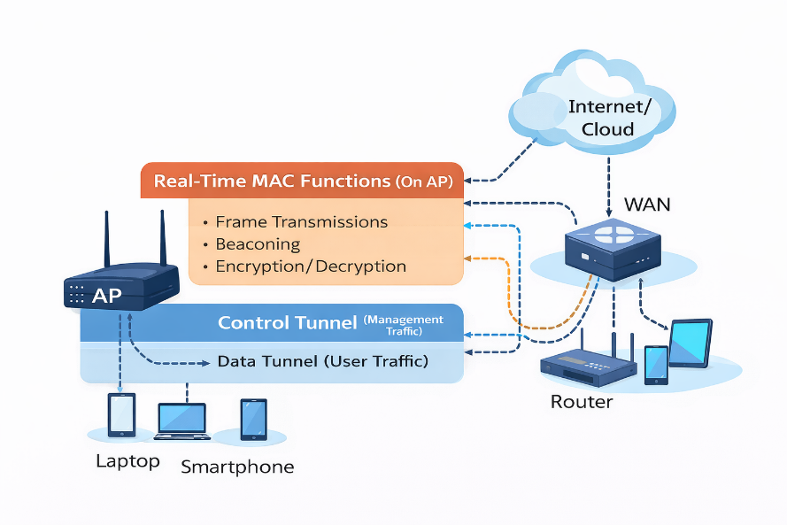

Explanation:
This architecture reduces the workload on individual APs and allows centralized control. It improves scalability, simplifies management, and enhances roaming performance in large networks.

2. CAPWAP Protocol and Flow
CAPWAP (Control and Provisioning of Wireless Access Points) is used for communication between AP and WLC.
Flow Process:
- AP discovers WLC (via DHCP/DNS)
- AP sends join request
- Authentication takes place
- WLC sends configuration to AP
- Data communication begins
Explanation:
CAPWAP ensures centralized configuration and secure communication between AP and controller.

3. CAPWAP in OSI Model and Tunnels
CAPWAP operates at Layer 3 (Network Layer) using UDP.
Two tunnels:
- Control Tunnel (UDP 5246):
  - Used for configuration and management
- Data Tunnel (UDP 5247):
  - Carries user data traffic
Explanation:
Separating control and data traffic improves efficiency and security.

4. Difference between Lightweight APs and Cloud-based APs
Feature | Lightweight AP | Cloud-based AP
Controller | On-premise | Cloud
Management | Local | Remote
Use Case | Enterprise | Distributed networks
Explanation:
Lightweight APs depend on local controllers, while cloud APs are managed remotely via the internet.

5. CAPWAP Tunnel Maintenance
CAPWAP tunnels are maintained using:
- Keepalive messages
- Heartbeat signals
- Secure communication using DTLS
Explanation:
If the connection fails, the AP attempts to reconnect automatically to maintain network stability.

6. Sniffer Mode vs Monitor Mode
Feature | Sniffer Mode | Monitor Mode
Function | Packet capture | Network monitoring
Use Case | Troubleshooting | Security detection
Explanation:
Sniffer mode is used for deep packet analysis, while monitor mode scans for network issues and rogue devices.

7. Best AP Mode when WLC is in WAN
FlexConnect mode is the best option.
Explanation:
It allows local switching of traffic, reduces WAN dependency, and ensures connectivity even if the controller is unreachable.

8. Challenges with Autonomous APs (>50 APs)
- No centralized management
- Difficult configuration updates
- Poor scalability
- High maintenance effort
Explanation:
Managing many standalone APs becomes complex and inefficient in large networks.

9. Behavior when WLC goes down (Local Mode AP)
- AP loses controller connection
- New clients cannot connect
- Existing clients may disconnect
Explanation:
Since control is centralized, the network becomes unavailable unless fallback mechanisms like FlexConnect are used.

